Internet and Web Programming

Lab Assignment 5

Name: Om Ashish Mishra

Registration Number: 16BCE0789

Slot: B2

# The Questions:

1. Write a java program to calculate gross salary & net salary taking the following data. Input: empno, empname, basic pay

Process: DA=50%of basic pay

HRA=25%of basic pay

CCA=Rs2000

PF=10%of basic pay

PT=Rs1800

1. Print the marksheet of the student using Single Inheritance.
2. Design a Base class Customer (name, phone-number).

Derive a class Depositor(accno,  balance) from Customer.   
Again, derive a class Borrower (loan-no, loan-amt) from Depositor.

Write necessary member functions to read and display the details of n

Customer.(Multilevel Inheritance)

1. Write a Java program to implement the employee hierarchy. Implement Run Time polymorphism by overriding the getDescription() method.

Add necessary fields.

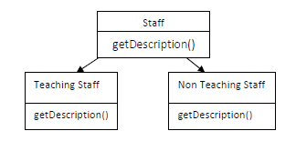

1. Create user defined package (Area) contain methods to calculate the area of the various shapes square, rectangle, sphere and triangle. Invoke these methods by importing this package in other java file.
2. Create a class to implement the subscription details(Monthly,quarterly,yearly) of customer for a cable TV connection using abstract class and interface.

* Include interface containing the method personal() and subscription().
* Include abstract class containing the abstract method disp_details().

# The Answers:

1.

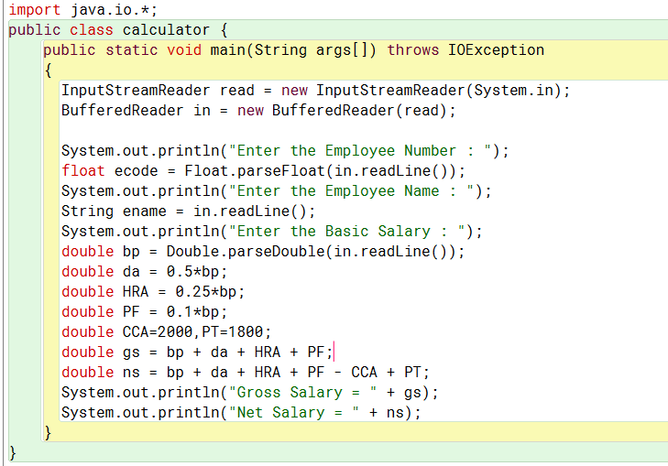

The Output:

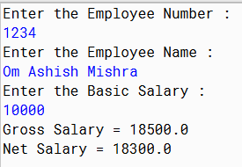

2.

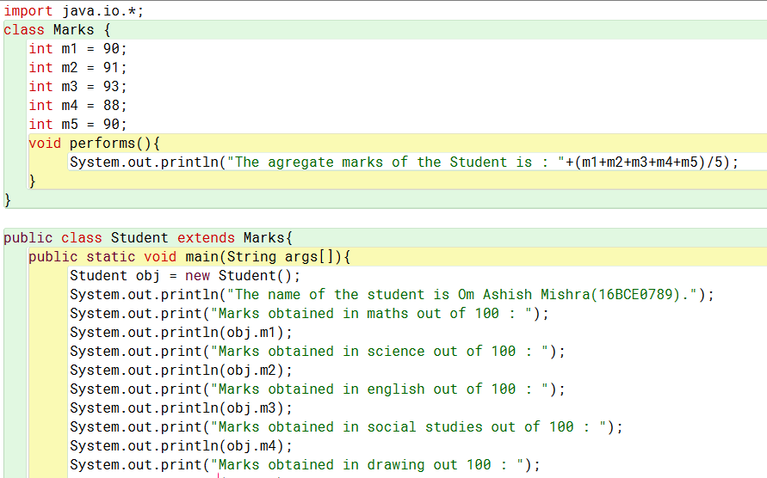

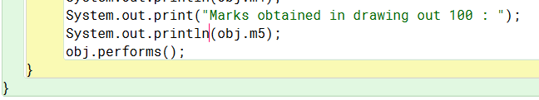

The output:

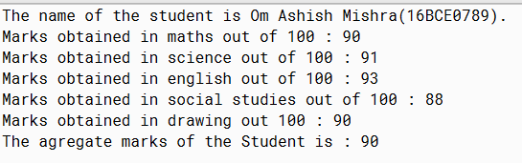

3.

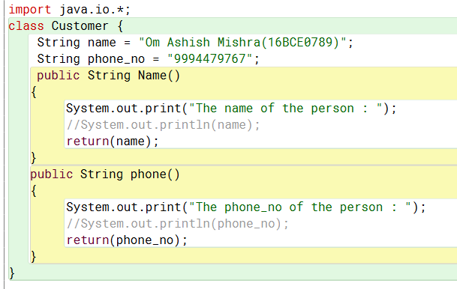

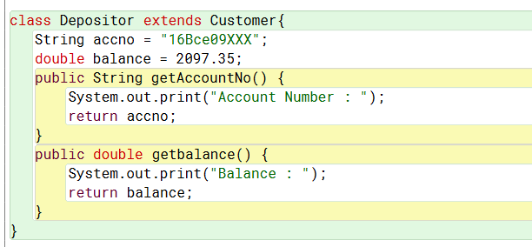

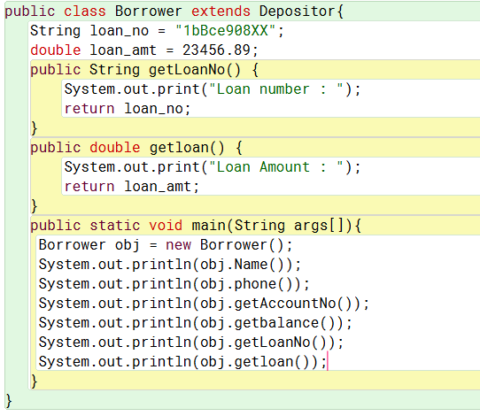

The Output:

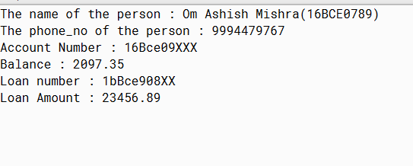

4.

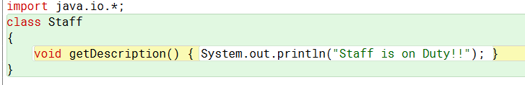

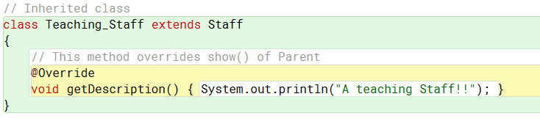

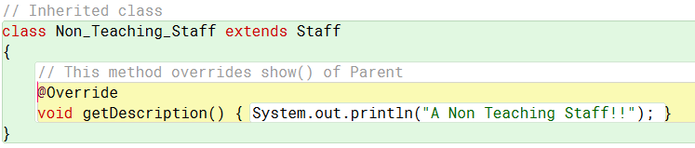

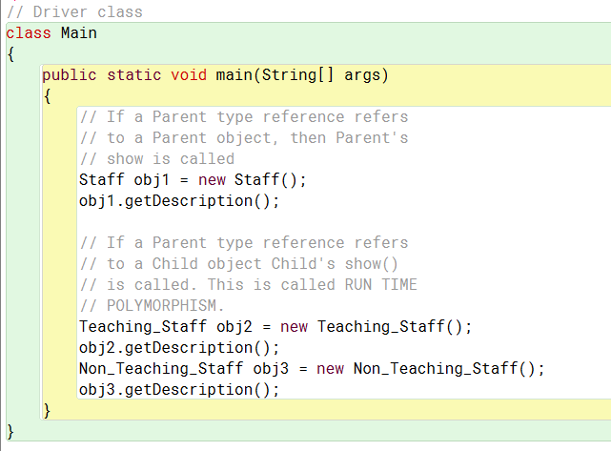

The Output:

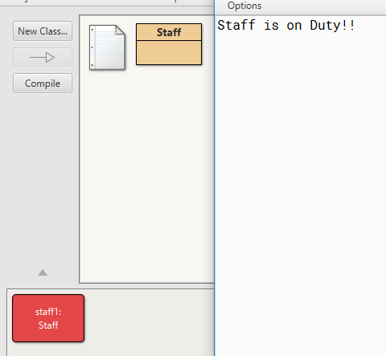

5.

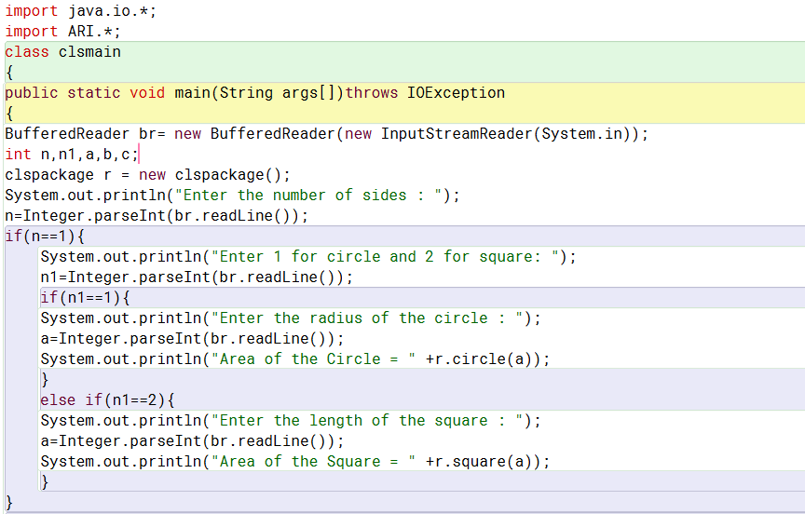

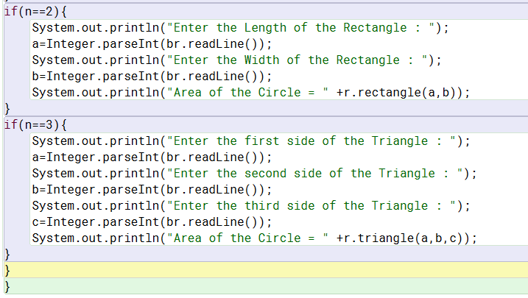

The Package creation:

package ARI;

import static java.lang.Math.sqrt;

public class clspackage {

public double circle(int a)

{

return(3.14*a*a);

}

public double rectangle(int b, int c)

{

return(b*c);

}

public double square(int d)

{

return(d*d);

}

public double triangle(int e, int f, int g)

{

double s = (e+f+g)/3;

double m = sqrt(s*(s-e)*(s-f)*(s-g));

return(m);

}

}

The Output:

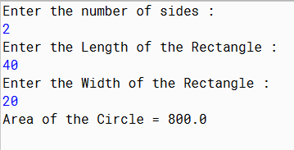

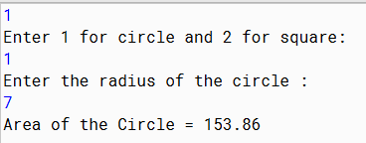

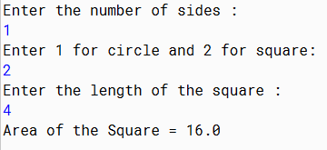

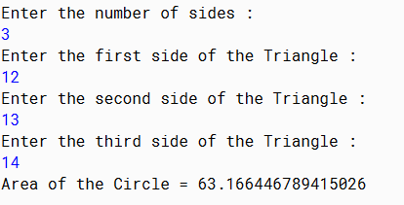

6.

